1 run......

training 1 epoch...

2.0151617527008057 seconds used......

1 training finished! average train loss: 1.1862954392152674

evaluating...

Confusion matrix, without normalization

[[ 39 1 1]

[ 92 2 1]

[590 31 93]]

Normalized confusion matrix

[[0.95121951 0.02439024 0.02439024]

[0.96842105 0.02105263 0.01052632]

[0.82633053 0.04341737 0.1302521 ]]

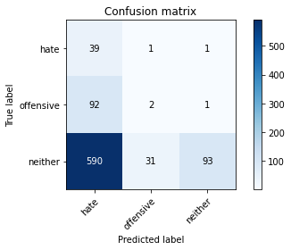

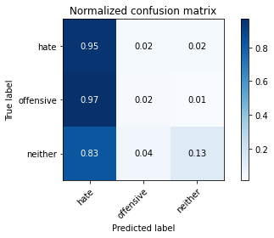

precision recall f1-score support

hate 0.05 0.95 0.10 41

offensive 0.06 0.02 0.03 95

neither 0.98 0.13 0.23 714

accuracy 0.16 850

macro avg 0.36 0.37 0.12 850

weighted avg 0.83 0.16 0.20 850

average eval_loss: 1.2040890593861424, accuracy: 0.15764705882352942

training 2 epoch...

1.9618124961853027 seconds used......

2 training finished! average train loss: 1.0279122205341564

evaluating...

Confusion matrix, without normalization

[[ 10 30 1]

[ 28 58 9]

[190 271 253]]

Normalized confusion matrix

[[0.24390244 0.73170732 0.02439024]

[0.29473684 0.61052632 0.09473684]

[0.26610644 0.37955182 0.35434174]]

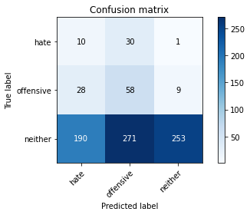

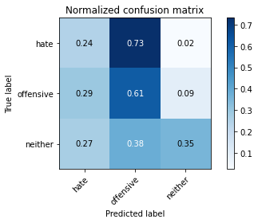

precision recall f1-score support

hate 0.04 0.24 0.07 41

offensive 0.16 0.61 0.26 95

neither 0.96 0.35 0.52 714

accuracy 0.38 850

macro avg 0.39 0.40 0.28 850

weighted avg 0.83 0.38 0.47 850

average eval_loss: 1.1305771165115888, accuracy: 0.3776470588235294

training 3 epoch...

1.9979512691497803 seconds used......

3 training finished! average train loss: 0.9284053690293256

evaluating...

Confusion matrix, without normalization

[[ 29 11 1]

[ 56 30 9]

[286 160 268]]

Normalized confusion matrix

[[0.70731707 0.26829268 0.02439024]

[0.58947368 0.31578947 0.09473684]

[0.40056022 0.22408964 0.37535014]]

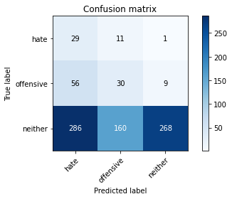

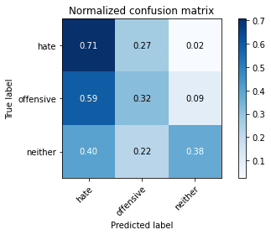

precision recall f1-score support

hate 0.08 0.71 0.14 41

offensive 0.15 0.32 0.20 95

neither 0.96 0.38 0.54 714

accuracy 0.38 850

macro avg 0.40 0.47 0.29 850

weighted avg 0.83 0.38 0.48 850

average eval_loss: 1.11407263680946, accuracy: 0.3847058823529412

training 4 epoch...

2.0026865005493164 seconds used......

4 training finished! average train loss: 0.7994083411553327

evaluating...

Confusion matrix, without normalization

[[ 4 34 3]

[ 4 84 7]

[ 68 417 229]]

Normalized confusion matrix

[[0.09756098 0.82926829 0.07317073]

[0.04210526 0.88421053 0.07368421]

[0.0952381 0.58403361 0.32072829]]

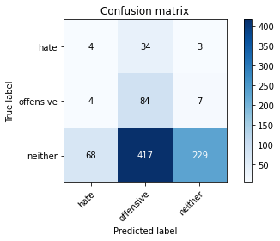

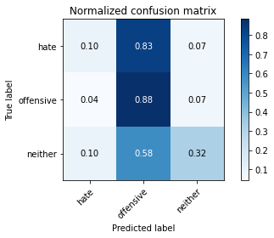

precision recall f1-score support

hate 0.05 0.10 0.07 41

offensive 0.16 0.88 0.27 95

neither 0.96 0.32 0.48 714

accuracy 0.37 850

macro avg 0.39 0.43 0.27 850

weighted avg 0.82 0.37 0.44 850

average eval_loss: 1.1935424250225688, accuracy: 0.3729411764705882

training 5 epoch...

1.9655873775482178 seconds used......

5 training finished! average train loss: 0.6718828327515546

evaluating...

Confusion matrix, without normalization

[[ 4 33 4]

[ 6 81 8]

[ 71 357 286]]

Normalized confusion matrix

[[0.09756098 0.80487805 0.09756098]

[0.06315789 0.85263158 0.08421053]

[0.09943978 0.5 0.40056022]]

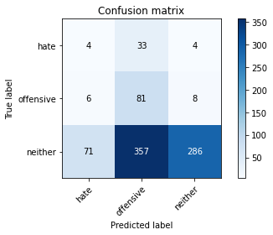

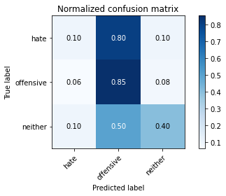

precision recall f1-score support

hate 0.05 0.10 0.07 41

offensive 0.17 0.85 0.29 95

neither 0.96 0.40 0.57 714

accuracy 0.44 850

macro avg 0.39 0.45 0.31 850

weighted avg 0.83 0.44 0.51 850

average eval_loss: 1.1188776905453481, accuracy: 0.4364705882352941

training 6 epoch...

1.9661965370178223 seconds used......

6 training finished! average train loss: 0.4998384118080139

evaluating...

Confusion matrix, without normalization

[[ 17 19 5]

[ 13 70 12]

[142 233 339]]

Normalized confusion matrix

[[0.41463415 0.46341463 0.12195122]

[0.13684211 0.73684211 0.12631579]

[0.19887955 0.32633053 0.47478992]]

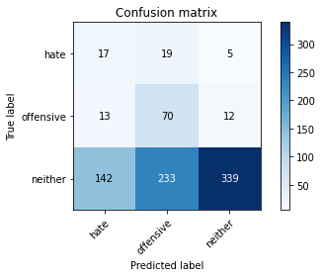

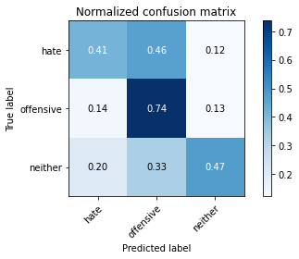

precision recall f1-score support

hate 0.10 0.41 0.16 41

offensive 0.22 0.74 0.34 95

neither 0.95 0.47 0.63 714

accuracy 0.50 850

macro avg 0.42 0.54 0.38 850

weighted avg 0.83 0.50 0.58 850

average eval_loss: 1.10474390207335, accuracy: 0.5011764705882353

training 7 epoch...

1.9540886878967285 seconds used......

7 training finished! average train loss: 0.3026366040987127

evaluating...

Confusion matrix, without normalization

[[ 24 9 8]

[ 26 45 24]

[173 130 411]]

Normalized confusion matrix

[[0.58536585 0.2195122 0.19512195]

[0.27368421 0.47368421 0.25263158]

[0.24229692 0.18207283 0.57563025]]

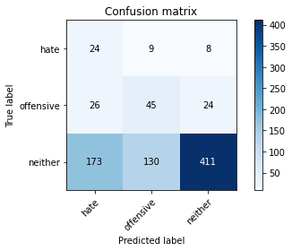

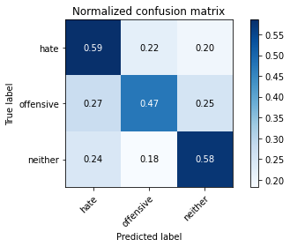

precision recall f1-score support

hate 0.11 0.59 0.18 41

offensive 0.24 0.47 0.32 95

neither 0.93 0.58 0.71 714

accuracy 0.56 850

macro avg 0.43 0.54 0.40 850

weighted avg 0.81 0.56 0.64 850

average eval_loss: 1.0537439745872519, accuracy: 0.5647058823529412

training 8 epoch...

1.9613656997680664 seconds used......

8 training finished! average train loss: 0.16089723171556697

evaluating...

Confusion matrix, without normalization

[[ 27 7 7]

[ 44 35 16]

[225 135 354]]

Normalized confusion matrix

[[0.65853659 0.17073171 0.17073171]

[0.46315789 0.36842105 0.16842105]

[0.31512605 0.18907563 0.49579832]]

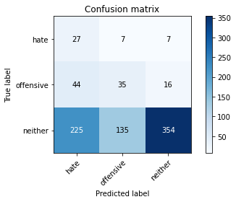

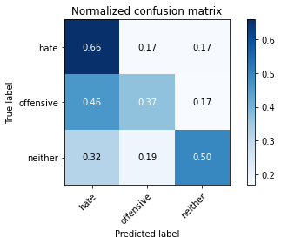

precision recall f1-score support

hate 0.09 0.66 0.16 41

offensive 0.20 0.37 0.26 95

neither 0.94 0.50 0.65 714

accuracy 0.49 850

macro avg 0.41 0.51 0.36 850

weighted avg 0.82 0.49 0.58 850

average eval_loss: 1.385793459363455, accuracy: 0.4894117647058824

training 9 epoch...

2.031599998474121 seconds used......

9 training finished! average train loss: 0.07916578562820659

evaluating...

Confusion matrix, without normalization

[[ 16 18 7]

[ 17 63 15]

[141 215 358]]

Normalized confusion matrix

[[0.3902439 0.43902439 0.17073171]

[0.17894737 0.66315789 0.15789474]

[0.19747899 0.30112045 0.50140056]]

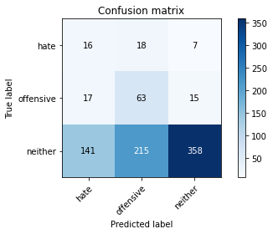

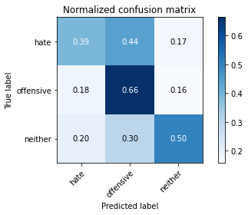

precision recall f1-score support

hate 0.09 0.39 0.15 41

offensive 0.21 0.66 0.32 95

neither 0.94 0.50 0.65 714

accuracy 0.51 850

macro avg 0.42 0.52 0.38 850

weighted avg 0.82 0.51 0.59 850

average eval_loss: 1.4114517905034645, accuracy: 0.5141176470588236

training 10 epoch...

2.0520293712615967 seconds used......

10 training finished! average train loss: 0.03522781216922928

evaluating...

Confusion matrix, without normalization

[[ 15 20 6]

[ 21 64 10]

[147 257 310]]

Normalized confusion matrix

[[0.36585366 0.48780488 0.14634146]

[0.22105263 0.67368421 0.10526316]

[0.20588235 0.35994398 0.43417367]]

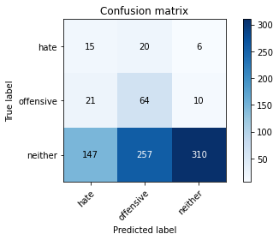

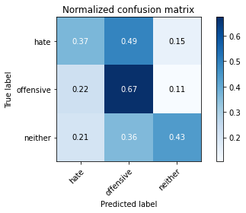

precision recall f1-score support

hate 0.08 0.37 0.13 41

offensive 0.19 0.67 0.29 95

neither 0.95 0.43 0.60 714

accuracy 0.46 850

macro avg 0.41 0.49 0.34 850

weighted avg 0.82 0.46 0.54 850

average eval_loss: 1.7893881874678785, accuracy: 0.4576470588235294

2 run......

training 1 epoch...

1.9751312732696533 seconds used......

1 training finished! average train loss: 1.2545589348849129

evaluating...

Confusion matrix, without normalization

[[ 12 27 2]

[ 11 59 25]

[ 94 444 176]]

Normalized confusion matrix

[[0.29268293 0.65853659 0.04878049]

[0.11578947 0.62105263 0.26315789]

[0.13165266 0.62184874 0.2464986 ]]

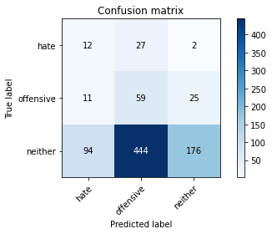

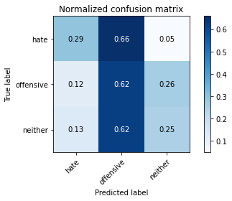

precision recall f1-score support

hate 0.10 0.29 0.15 41

offensive 0.11 0.62 0.19 95

neither 0.87 0.25 0.38 714

accuracy 0.29 850

macro avg 0.36 0.39 0.24 850

weighted avg 0.75 0.29 0.35 850

average eval_loss: 1.1610314042069192, accuracy: 0.29058823529411765

training 2 epoch...

1.9396488666534424 seconds used......

2 training finished! average train loss: 1.0425369143486023

evaluating...

Confusion matrix, without normalization

[[ 21 19 1]

[ 49 43 3]

[275 296 143]]

Normalized confusion matrix

[[0.51219512 0.46341463 0.02439024]

[0.51578947 0.45263158 0.03157895]

[0.38515406 0.41456583 0.20028011]]

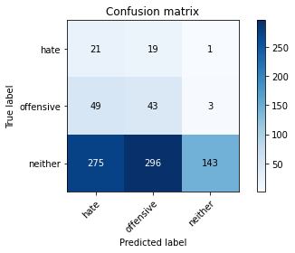

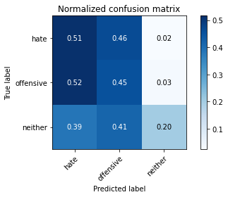

precision recall f1-score support

hate 0.06 0.51 0.11 41

offensive 0.12 0.45 0.19 95

neither 0.97 0.20 0.33 714

accuracy 0.24 850

macro avg 0.38 0.39 0.21 850

weighted avg 0.83 0.24 0.31 850

average eval_loss: 1.221562848534695, accuracy: 0.24352941176470588

training 3 epoch...

1.958601951599121 seconds used......

3 training finished! average train loss: 0.9508901308564579

evaluating...

Confusion matrix, without normalization

[[ 19 21 1]

[ 37 44 14]

[228 274 212]]

Normalized confusion matrix

[[0.46341463 0.51219512 0.02439024]

[0.38947368 0.46315789 0.14736842]

[0.31932773 0.3837535 0.29691877]]

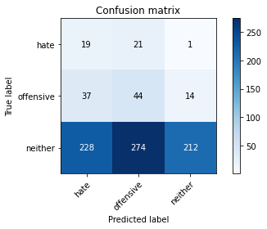

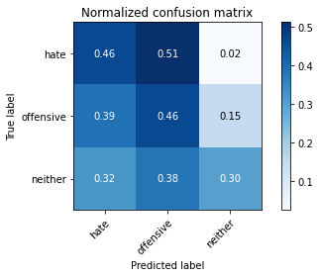

precision recall f1-score support

hate 0.07 0.46 0.12 41

offensive 0.13 0.46 0.20 95

neither 0.93 0.30 0.45 714

accuracy 0.32 850

macro avg 0.38 0.41 0.26 850

weighted avg 0.80 0.32 0.41 850

average eval_loss: 1.154947501628898, accuracy: 0.3235294117647059

training 4 epoch...

1.960580825805664 seconds used......

4 training finished! average train loss: 0.8212659253793604

evaluating...

Confusion matrix, without normalization

[[ 18 21 2]

[ 32 58 5]

[214 313 187]]

Normalized confusion matrix

[[0.43902439 0.51219512 0.04878049]

[0.33684211 0.61052632 0.05263158]

[0.29971989 0.43837535 0.26190476]]

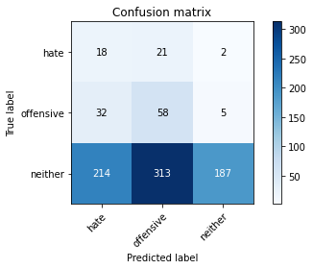

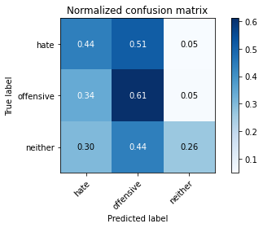

precision recall f1-score support

hate 0.07 0.44 0.12 41

offensive 0.15 0.61 0.24 95

neither 0.96 0.26 0.41 714

accuracy 0.31 850

macro avg 0.39 0.44 0.26 850

weighted avg 0.83 0.31 0.38 850

average eval_loss: 1.2950382697027782, accuracy: 0.30941176470588233

training 5 epoch...

1.9441907405853271 seconds used......

5 training finished! average train loss: 0.6493685333167806

evaluating...

Confusion matrix, without normalization

[[ 15 19 7]

[ 16 47 32]

[143 200 371]]

Normalized confusion matrix

[[0.36585366 0.46341463 0.17073171]

[0.16842105 0.49473684 0.33684211]

[0.20028011 0.28011204 0.51960784]]

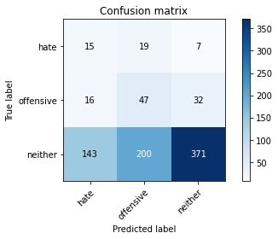

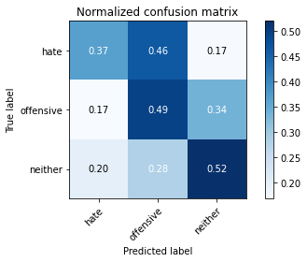

precision recall f1-score support

hate 0.09 0.37 0.14 41

offensive 0.18 0.49 0.26 95

neither 0.90 0.52 0.66 714

accuracy 0.51 850

macro avg 0.39 0.46 0.35 850

weighted avg 0.78 0.51 0.59 850

average eval_loss: 0.9662843772838282, accuracy: 0.5094117647058823

training 6 epoch...

1.9563050270080566 seconds used......

6 training finished! average train loss: 0.4587725032778347

evaluating...

Confusion matrix, without normalization

[[ 15 20 6]

[ 15 58 22]

[139 259 316]]

Normalized confusion matrix

[[0.36585366 0.48780488 0.14634146]

[0.15789474 0.61052632 0.23157895]

[0.19467787 0.3627451 0.44257703]]

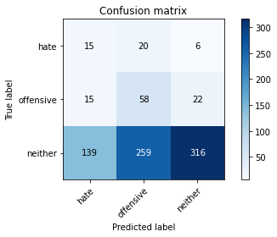

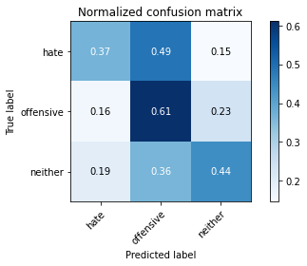

precision recall f1-score support

hate 0.09 0.37 0.14 41

offensive 0.17 0.61 0.27 95

neither 0.92 0.44 0.60 714

accuracy 0.46 850

macro avg 0.39 0.47 0.34 850

weighted avg 0.80 0.46 0.54 850

average eval_loss: 1.1797423331543457, accuracy: 0.4576470588235294

training 7 epoch...

1.9637928009033203 seconds used......

7 training finished! average train loss: 0.24800949499887578

evaluating...

Confusion matrix, without normalization

[[ 15 17 9]

[ 14 57 24]

[131 197 386]]

Normalized confusion matrix

[[0.36585366 0.41463415 0.2195122 ]

[0.14736842 0.6 0.25263158]

[0.18347339 0.27591036 0.54061625]]

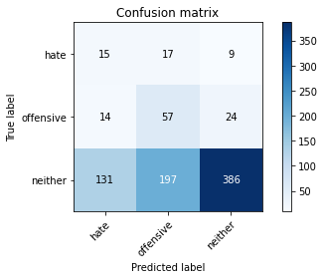

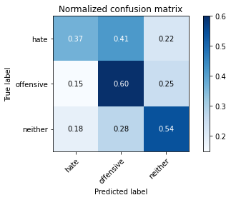

precision recall f1-score support

hate 0.09 0.37 0.15 41

offensive 0.21 0.60 0.31 95

neither 0.92 0.54 0.68 714

accuracy 0.54 850

macro avg 0.41 0.50 0.38 850

weighted avg 0.80 0.54 0.61 850

average eval_loss: 1.091316926617955, accuracy: 0.5388235294117647

training 8 epoch...

1.9644880294799805 seconds used......

8 training finished! average train loss: 0.13842806614497127

evaluating...

Confusion matrix, without normalization

[[ 16 16 9]

[ 23 50 22]

[174 183 357]]

Normalized confusion matrix

[[0.3902439 0.3902439 0.2195122 ]

[0.24210526 0.52631579 0.23157895]

[0.24369748 0.25630252 0.5 ]]

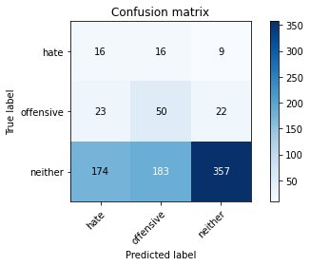

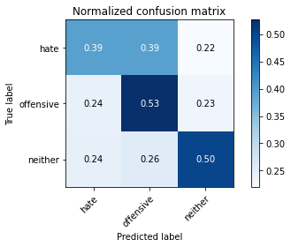

precision recall f1-score support

hate 0.08 0.39 0.13 41

offensive 0.20 0.53 0.29 95

neither 0.92 0.50 0.65 714

accuracy 0.50 850

macro avg 0.40 0.47 0.35 850

weighted avg 0.80 0.50 0.58 850

average eval_loss: 1.357399636576342, accuracy: 0.4976470588235294

training 9 epoch...

1.9478843212127686 seconds used......

9 training finished! average train loss: 0.06382268513826762

evaluating...

Confusion matrix, without normalization

[[ 17 17 7]

[ 25 59 11]

[201 236 277]]

Normalized confusion matrix

[[0.41463415 0.41463415 0.17073171]

[0.26315789 0.62105263 0.11578947]

[0.28151261 0.33053221 0.38795518]]

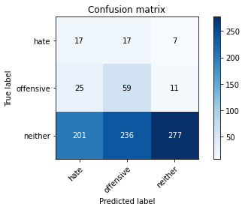

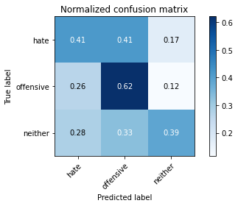

precision recall f1-score support

hate 0.07 0.41 0.12 41

offensive 0.19 0.62 0.29 95

neither 0.94 0.39 0.55 714

accuracy 0.42 850

macro avg 0.40 0.47 0.32 850

weighted avg 0.81 0.42 0.50 850

average eval_loss: 1.850916288793087, accuracy: 0.4152941176470588

training 10 epoch...

1.9567358493804932 seconds used......

10 training finished! average train loss: 0.03459963049082195

evaluating...

Confusion matrix, without normalization

[[ 18 16 7]

[ 20 60 15]

[187 222 305]]

Normalized confusion matrix

[[0.43902439 0.3902439 0.17073171]

[0.21052632 0.63157895 0.15789474]

[0.26190476 0.31092437 0.42717087]]

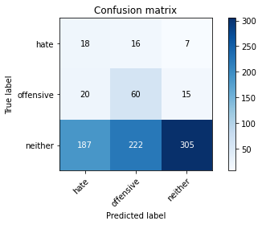

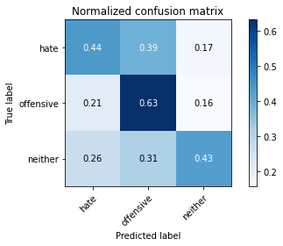

precision recall f1-score support

hate 0.08 0.44 0.14 41

offensive 0.20 0.63 0.31 95

neither 0.93 0.43 0.59 714

accuracy 0.45 850

macro avg 0.40 0.50 0.34 850

weighted avg 0.81 0.45 0.53 850

average eval_loss: 1.8197899898730738, accuracy: 0.4505882352941176

3 run......

training 1 epoch...

2.034043788909912 seconds used......

1 training finished! average train loss: 1.2331296415889965

evaluating...

Confusion matrix, without normalization

[[ 15 24 2]

[ 11 53 31]

[177 225 312]]

Normalized confusion matrix

[[0.36585366 0.58536585 0.04878049]

[0.11578947 0.55789474 0.32631579]

[0.24789916 0.31512605 0.43697479]]

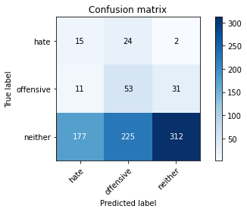

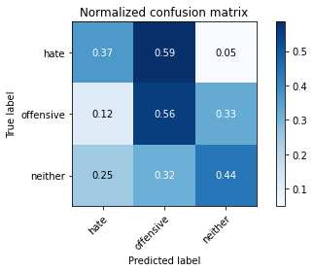

precision recall f1-score support

hate 0.07 0.37 0.12 41

offensive 0.18 0.56 0.27 95

neither 0.90 0.44 0.59 714

accuracy 0.45 850

macro avg 0.38 0.45 0.33 850

weighted avg 0.78 0.45 0.53 850

average eval_loss: 1.0950268895127053, accuracy: 0.4470588235294118

training 2 epoch...

1.9622306823730469 seconds used......

2 training finished! average train loss: 1.04275079685099

evaluating...

Confusion matrix, without normalization

[[ 17 22 2]

[ 14 32 49]

[163 207 344]]

Normalized confusion matrix

[[0.41463415 0.53658537 0.04878049]

[0.14736842 0.33684211 0.51578947]

[0.22829132 0.28991597 0.48179272]]

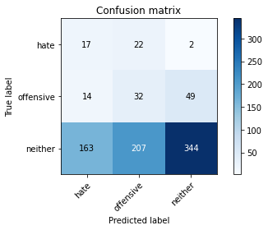

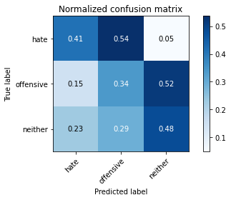

precision recall f1-score support

hate 0.09 0.41 0.14 41

offensive 0.12 0.34 0.18 95

neither 0.87 0.48 0.62 714

accuracy 0.46 850

macro avg 0.36 0.41 0.31 850

weighted avg 0.75 0.46 0.55 850

average eval_loss: 1.0597438403340274, accuracy: 0.4623529411764706

training 3 epoch...

2.2133073806762695 seconds used......

3 training finished! average train loss: 0.9537507330670076

evaluating...

Confusion matrix, without normalization

[[ 20 20 1]

[ 36 56 3]

[268 287 159]]

Normalized confusion matrix

[[0.48780488 0.48780488 0.02439024]

[0.37894737 0.58947368 0.03157895]

[0.37535014 0.40196078 0.22268908]]

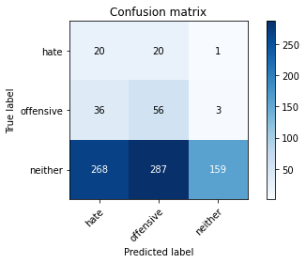

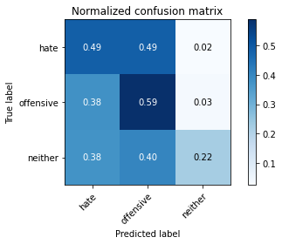

precision recall f1-score support

hate 0.06 0.49 0.11 41

offensive 0.15 0.59 0.24 95

neither 0.98 0.22 0.36 714

accuracy 0.28 850

macro avg 0.40 0.43 0.24 850

weighted avg 0.84 0.28 0.34 850

average eval_loss: 1.2466947048209434, accuracy: 0.27647058823529413

training 4 epoch...

1.953188419342041 seconds used......

4 training finished! average train loss: 0.8427611414123984

evaluating...

Confusion matrix, without normalization

[[ 17 23 1]

[ 21 69 5]

[166 312 236]]

Normalized confusion matrix

[[0.41463415 0.56097561 0.02439024]

[0.22105263 0.72631579 0.05263158]

[0.232493 0.43697479 0.33053221]]

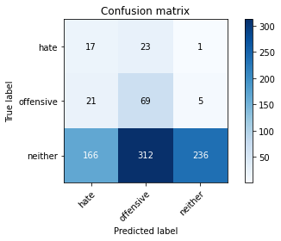

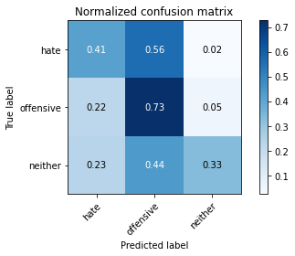

precision recall f1-score support

hate 0.08 0.41 0.14 41

offensive 0.17 0.73 0.28 95

neither 0.98 0.33 0.49 714

accuracy 0.38 850

macro avg 0.41 0.49 0.30 850

weighted avg 0.84 0.38 0.45 850

average eval_loss: 1.1302183679369993, accuracy: 0.3788235294117647

training 5 epoch...

2.0048434734344482 seconds used......

5 training finished! average train loss: 0.6854689226431006

evaluating...

Confusion matrix, without normalization

[[ 20 17 4]

[ 18 68 9]

[160 269 285]]

Normalized confusion matrix

[[0.48780488 0.41463415 0.09756098]

[0.18947368 0.71578947 0.09473684]

[0.22408964 0.3767507 0.39915966]]

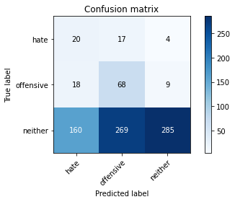

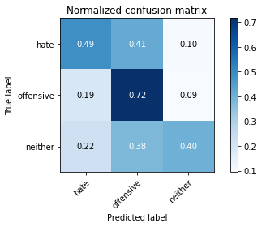

precision recall f1-score support

hate 0.10 0.49 0.17 41

offensive 0.19 0.72 0.30 95

neither 0.96 0.40 0.56 714

accuracy 0.44 850

macro avg 0.42 0.53 0.34 850

weighted avg 0.83 0.44 0.52 850

average eval_loss: 1.0663116480721984, accuracy: 0.4388235294117647

training 6 epoch...

1.9501206874847412 seconds used......

6 training finished! average train loss: 0.5019779643591713

evaluating...

Confusion matrix, without normalization

[[ 24 13 4]

[ 26 61 8]

[204 213 297]]

Normalized confusion matrix

[[0.58536585 0.31707317 0.09756098]

[0.27368421 0.64210526 0.08421053]

[0.28571429 0.29831933 0.41596639]]

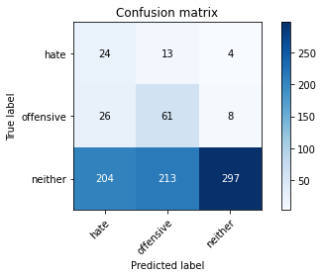

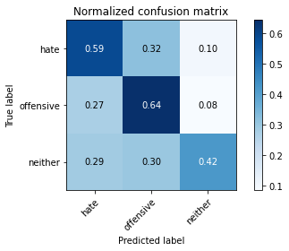

precision recall f1-score support

hate 0.09 0.59 0.16 41

offensive 0.21 0.64 0.32 95

neither 0.96 0.42 0.58 714

accuracy 0.45 850

macro avg 0.42 0.55 0.35 850

weighted avg 0.84 0.45 0.53 850

average eval_loss: 1.1729060915666958, accuracy: 0.44941176470588234

training 7 epoch...

2.0213961601257324 seconds used......

7 training finished! average train loss: 0.27931473973919363

evaluating...

Confusion matrix, without normalization

[[ 27 6 8]

[ 47 34 14]

[270 120 324]]

Normalized confusion matrix

[[0.65853659 0.14634146 0.19512195]

[0.49473684 0.35789474 0.14736842]

[0.37815126 0.16806723 0.45378151]]

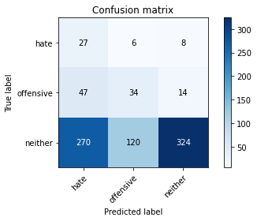

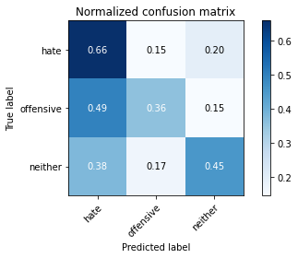

precision recall f1-score support

hate 0.08 0.66 0.14 41

offensive 0.21 0.36 0.27 95

neither 0.94 0.45 0.61 714

accuracy 0.45 850

macro avg 0.41 0.49 0.34 850

weighted avg 0.81 0.45 0.55 850

average eval_loss: 1.3288363790096238, accuracy: 0.45294117647058824

training 8 epoch...

1.9478743076324463 seconds used......

8 training finished! average train loss: 0.14003318942645016

evaluating...

Confusion matrix, without normalization

[[ 22 11 8]

[ 37 44 14]

[218 154 342]]

Normalized confusion matrix

[[0.53658537 0.26829268 0.19512195]

[0.38947368 0.46315789 0.14736842]

[0.30532213 0.21568627 0.4789916 ]]

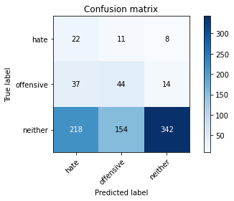

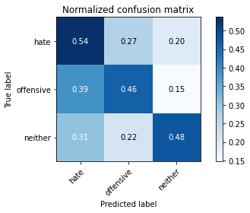

precision recall f1-score support

hate 0.08 0.54 0.14 41

offensive 0.21 0.46 0.29 95

neither 0.94 0.48 0.63 714

accuracy 0.48 850

macro avg 0.41 0.49 0.35 850

weighted avg 0.82 0.48 0.57 850

average eval_loss: 1.448667940423759, accuracy: 0.48

training 9 epoch...

2.0008249282836914 seconds used......

9 training finished! average train loss: 0.07450852455461726

evaluating...

Confusion matrix, without normalization

[[ 23 11 7]

[ 42 48 5]

[265 191 258]]

Normalized confusion matrix

[[0.56097561 0.26829268 0.17073171]

[0.44210526 0.50526316 0.05263158]

[0.37114846 0.267507 0.36134454]]

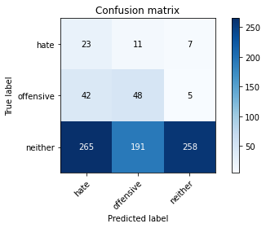

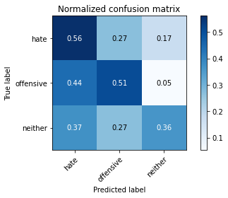

precision recall f1-score support

hate 0.07 0.56 0.12 41

offensive 0.19 0.51 0.28 95

neither 0.96 0.36 0.52 714

accuracy 0.39 850

macro avg 0.41 0.48 0.31 850

weighted avg 0.83 0.39 0.48 850

average eval_loss: 2.0982112482103497, accuracy: 0.3870588235294118

training 10 epoch...

1.954664707183838 seconds used......

10 training finished! average train loss: 0.029072520213530344

evaluating...

Confusion matrix, without normalization

[[ 21 11 9]

[ 28 58 9]

[192 204 318]]

Normalized confusion matrix

[[0.51219512 0.26829268 0.2195122 ]

[0.29473684 0.61052632 0.09473684]

[0.26890756 0.28571429 0.44537815]]

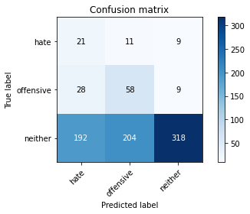

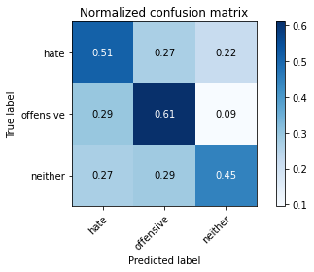

precision recall f1-score support

hate 0.09 0.51 0.15 41

offensive 0.21 0.61 0.32 95

neither 0.95 0.45 0.61 714

accuracy 0.47 850

macro avg 0.42 0.52 0.36 850

weighted avg 0.82 0.47 0.55 850

average eval_loss: 1.7905985822597907, accuracy: 0.46705882352941175

4 run......

training 1 epoch...

2.0727546215057373 seconds used......

1 training finished! average train loss: 1.1697836974087883

evaluating...

Confusion matrix, without normalization

[[ 37 3 1]

[ 91 2 2]

[554 50 110]]

Normalized confusion matrix

[[0.90243902 0.07317073 0.02439024]

[0.95789474 0.02105263 0.02105263]

[0.77591036 0.07002801 0.15406162]]

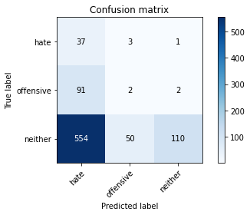

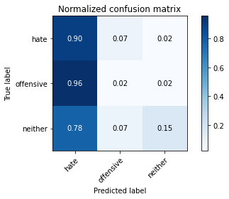

precision recall f1-score support

hate 0.05 0.90 0.10 41

offensive 0.04 0.02 0.03 95

neither 0.97 0.15 0.27 714

accuracy 0.18 850

macro avg 0.35 0.36 0.13 850

weighted avg 0.82 0.18 0.23 850

average eval_loss: 1.208046820274619, accuracy: 0.17529411764705882

training 2 epoch...

1.9599556922912598 seconds used......

2 training finished! average train loss: 1.026860047789181

evaluating...

Confusion matrix, without normalization

[[ 25 15 1]

[ 59 28 8]

[299 233 182]]

Normalized confusion matrix

[[0.6097561 0.36585366 0.02439024]

[0.62105263 0.29473684 0.08421053]

[0.41876751 0.32633053 0.25490196]]

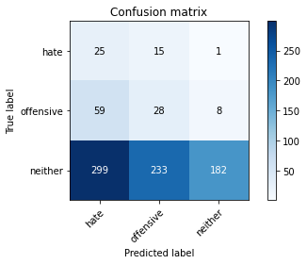

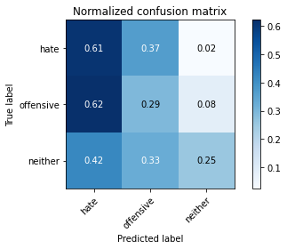

precision recall f1-score support

hate 0.07 0.61 0.12 41

offensive 0.10 0.29 0.15 95

neither 0.95 0.25 0.40 714

accuracy 0.28 850

macro avg 0.37 0.39 0.22 850

weighted avg 0.81 0.28 0.36 850

average eval_loss: 1.2011297497638436, accuracy: 0.27647058823529413

training 3 epoch...

1.9513487815856934 seconds used......

3 training finished! average train loss: 0.9161479543237125

evaluating...

Confusion matrix, without normalization

[[ 23 14 4]

[ 25 25 45]

[159 177 378]]

Normalized confusion matrix

[[0.56097561 0.34146341 0.09756098]

[0.26315789 0.26315789 0.47368421]

[0.22268908 0.24789916 0.52941176]]

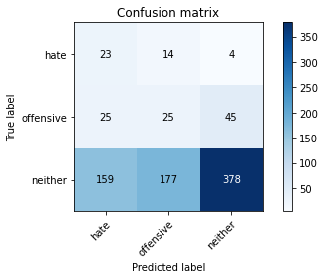

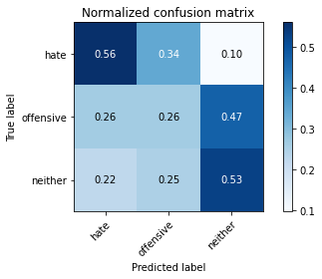

precision recall f1-score support

hate 0.11 0.56 0.19 41

offensive 0.12 0.26 0.16 95

neither 0.89 0.53 0.66 714

accuracy 0.50 850

macro avg 0.37 0.45 0.34 850

weighted avg 0.76 0.50 0.58 850

average eval_loss: 0.986833646200424, accuracy: 0.5011764705882353

training 4 epoch...

1.942112922668457 seconds used......

4 training finished! average train loss: 0.7620402048615849

evaluating...

Confusion matrix, without normalization

[[ 15 18 8]

[ 8 45 42]

[ 94 169 451]]

Normalized confusion matrix

[[0.36585366 0.43902439 0.19512195]

[0.08421053 0.47368421 0.44210526]

[0.13165266 0.23669468 0.63165266]]

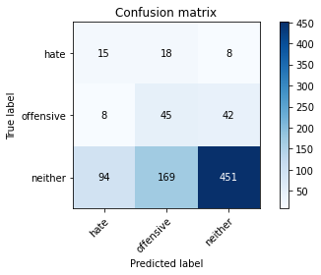

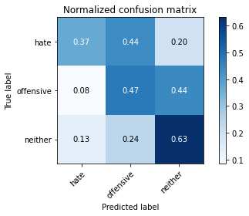

precision recall f1-score support

hate 0.13 0.37 0.19 41

offensive 0.19 0.47 0.28 95

neither 0.90 0.63 0.74 714

accuracy 0.60 850

macro avg 0.41 0.49 0.40 850

weighted avg 0.78 0.60 0.66 850

average eval_loss: 0.8509601077368093, accuracy: 0.6011764705882353

training 5 epoch...

1.944615364074707 seconds used......

5 training finished! average train loss: 0.6112140364506665

evaluating...

Confusion matrix, without normalization

[[ 23 8 10]

[ 20 17 58]

[146 94 474]]

Normalized confusion matrix

[[0.56097561 0.19512195 0.24390244]

[0.21052632 0.17894737 0.61052632]

[0.20448179 0.13165266 0.66386555]]

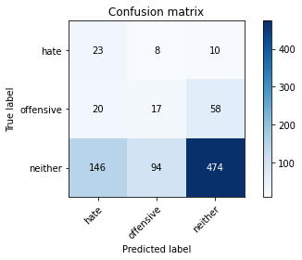

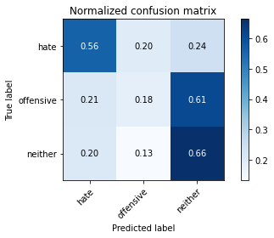

precision recall f1-score support

hate 0.12 0.56 0.20 41

offensive 0.14 0.18 0.16 95

neither 0.87 0.66 0.75 714

accuracy 0.60 850

macro avg 0.38 0.47 0.37 850

weighted avg 0.76 0.60 0.66 850

average eval_loss: 0.8559662665045539, accuracy: 0.6047058823529412

training 6 epoch...

1.9492790699005127 seconds used......

6 training finished! average train loss: 0.40349487434415254

evaluating...

Confusion matrix, without normalization

[[ 22 11 8]

[ 26 57 12]

[170 159 385]]

Normalized confusion matrix

[[0.53658537 0.26829268 0.19512195]

[0.27368421 0.6 0.12631579]

[0.23809524 0.22268908 0.53921569]]

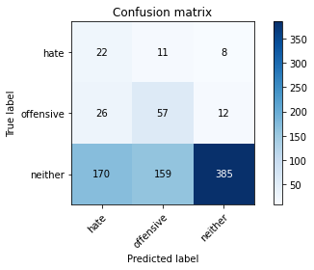

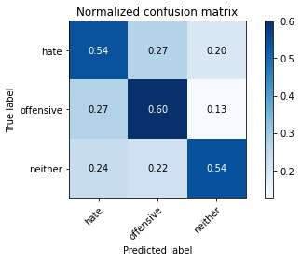

precision recall f1-score support

hate 0.10 0.54 0.17 41

offensive 0.25 0.60 0.35 95

neither 0.95 0.54 0.69 714

accuracy 0.55 850

macro avg 0.43 0.56 0.40 850

weighted avg 0.83 0.55 0.63 850

average eval_loss: 1.0277631000377412, accuracy: 0.5458823529411765

training 7 epoch...

2.0153918266296387 seconds used......

7 training finished! average train loss: 0.24362028784611645

evaluating...

Confusion matrix, without normalization

[[ 15 19 7]

[ 20 63 12]

[133 222 359]]

Normalized confusion matrix

[[0.36585366 0.46341463 0.17073171]

[0.21052632 0.66315789 0.12631579]

[0.18627451 0.31092437 0.50280112]]

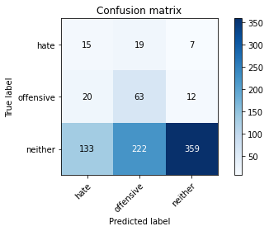

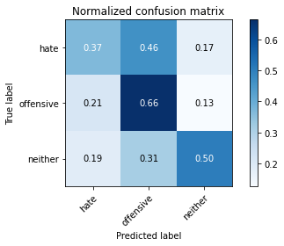

precision recall f1-score support

hate 0.09 0.37 0.14 41

offensive 0.21 0.66 0.32 95

neither 0.95 0.50 0.66 714

accuracy 0.51 850

macro avg 0.42 0.51 0.37 850

weighted avg 0.83 0.51 0.59 850

average eval_loss: 1.154871641376684, accuracy: 0.5141176470588236

training 8 epoch...

1.9640552997589111 seconds used......

8 training finished! average train loss: 0.11823868488564211

evaluating...

Confusion matrix, without normalization

[[ 17 16 8]

[ 27 61 7]

[184 213 317]]

Normalized confusion matrix

[[0.41463415 0.3902439 0.19512195]

[0.28421053 0.64210526 0.07368421]

[0.25770308 0.29831933 0.44397759]]

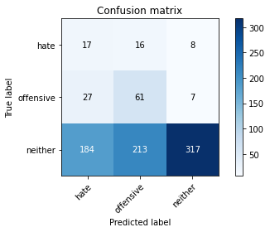

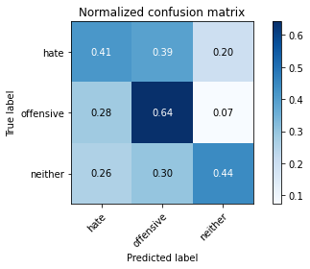

precision recall f1-score support

hate 0.07 0.41 0.13 41

offensive 0.21 0.64 0.32 95

neither 0.95 0.44 0.61 714

accuracy 0.46 850

macro avg 0.41 0.50 0.35 850

weighted avg 0.83 0.46 0.55 850

average eval_loss: 1.473964040535827, accuracy: 0.4647058823529412

training 9 epoch...

1.951066255569458 seconds used......

9 training finished! average train loss: 0.0540950951330802

evaluating...

Confusion matrix, without normalization

[[ 21 11 9]

[ 29 55 11]

[208 153 353]]

Normalized confusion matrix

[[0.51219512 0.26829268 0.2195122 ]

[0.30526316 0.57894737 0.11578947]

[0.29131653 0.21428571 0.49439776]]

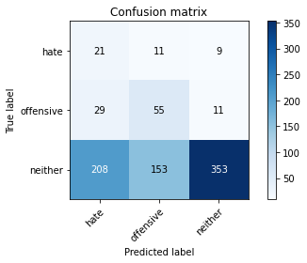

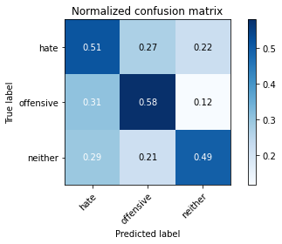

precision recall f1-score support

hate 0.08 0.51 0.14 41

offensive 0.25 0.58 0.35 95

neither 0.95 0.49 0.65 714

accuracy 0.50 850

macro avg 0.43 0.53 0.38 850

weighted avg 0.83 0.50 0.59 850

average eval_loss: 1.568868824302457, accuracy: 0.5047058823529412

training 10 epoch...

1.9434728622436523 seconds used......

10 training finished! average train loss: 0.030756728449726805

evaluating...

Confusion matrix, without normalization

[[ 18 14 9]

[ 27 60 8]

[187 189 338]]

Normalized confusion matrix

[[0.43902439 0.34146341 0.2195122 ]

[0.28421053 0.63157895 0.08421053]

[0.26190476 0.26470588 0.47338936]]

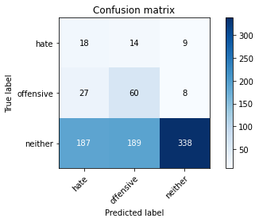

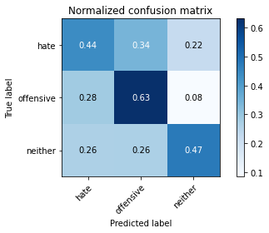

precision recall f1-score support

hate 0.08 0.44 0.13 41

offensive 0.23 0.63 0.34 95

neither 0.95 0.47 0.63 714

accuracy 0.49 850

macro avg 0.42 0.51 0.37 850

weighted avg 0.83 0.49 0.58 850

average eval_loss: 1.7120169826544995, accuracy: 0.4894117647058824

5 run......

training 1 epoch...

1.9714958667755127 seconds used......

1 training finished! average train loss: 1.19776811319239

evaluating...

Confusion matrix, without normalization

[[ 31 8 2]

[ 83 2 10]

[375 110 229]]

Normalized confusion matrix

[[0.75609756 0.19512195 0.04878049]

[0.87368421 0.02105263 0.10526316]

[0.52521008 0.15406162 0.32072829]]

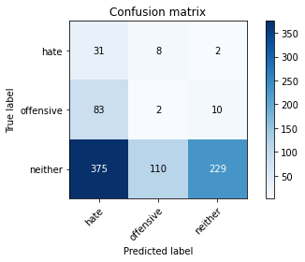

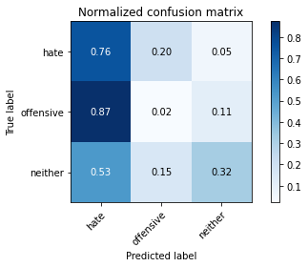

precision recall f1-score support

hate 0.06 0.76 0.12 41

offensive 0.02 0.02 0.02 95

neither 0.95 0.32 0.48 714

accuracy 0.31 850

macro avg 0.34 0.37 0.21 850

weighted avg 0.80 0.31 0.41 850

average eval_loss: 1.1307688424753588, accuracy: 0.30823529411764705

training 2 epoch...

1.9755566120147705 seconds used......

2 training finished! average train loss: 1.0429470363785238

evaluating...

Confusion matrix, without normalization

[[ 24 16 1]

[ 81 11 3]

[363 218 133]]

Normalized confusion matrix

[[0.58536585 0.3902439 0.02439024]

[0.85263158 0.11578947 0.03157895]

[0.50840336 0.30532213 0.18627451]]

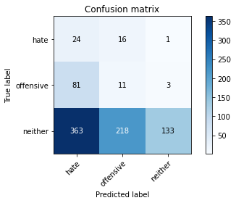

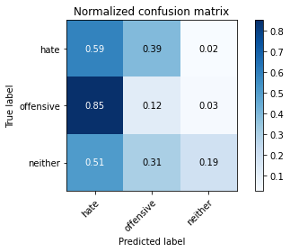

precision recall f1-score support

hate 0.05 0.59 0.09 41

offensive 0.04 0.12 0.06 95

neither 0.97 0.19 0.31 714

accuracy 0.20 850

macro avg 0.36 0.30 0.16 850

weighted avg 0.82 0.20 0.27 850

average eval_loss: 1.275168393933496, accuracy: 0.1976470588235294

training 3 epoch...

1.9580504894256592 seconds used......

3 training finished! average train loss: 0.9238748690661263

evaluating...

Confusion matrix, without normalization

[[ 24 16 1]

[ 54 33 8]

[256 215 243]]

Normalized confusion matrix

[[0.58536585 0.3902439 0.02439024]

[0.56842105 0.34736842 0.08421053]

[0.35854342 0.30112045 0.34033613]]

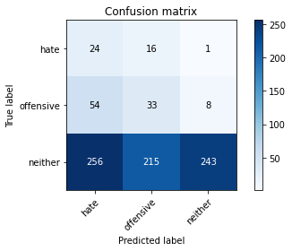

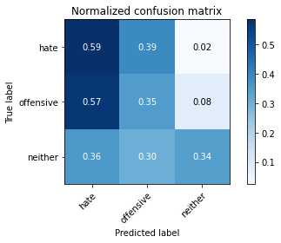

precision recall f1-score support

hate 0.07 0.59 0.13 41

offensive 0.12 0.35 0.18 95

neither 0.96 0.34 0.50 714

accuracy 0.35 850

macro avg 0.39 0.42 0.27 850

weighted avg 0.83 0.35 0.45 850

average eval_loss: 1.123358127682708, accuracy: 0.35294117647058826

training 4 epoch...

1.980931282043457 seconds used......

4 training finished! average train loss: 0.8010972177281099

evaluating...

Confusion matrix, without normalization

[[ 28 12 1]

[ 48 46 1]

[363 238 113]]

Normalized confusion matrix

[[0.68292683 0.29268293 0.02439024]

[0.50526316 0.48421053 0.01052632]

[0.50840336 0.33333333 0.15826331]]

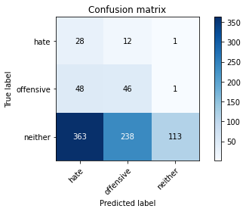

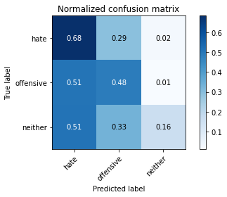

precision recall f1-score support

hate 0.06 0.68 0.12 41

offensive 0.16 0.48 0.24 95

neither 0.98 0.16 0.27 714

accuracy 0.22 850

macro avg 0.40 0.44 0.21 850

weighted avg 0.85 0.22 0.26 850

average eval_loss: 1.515865790982579, accuracy: 0.22

training 5 epoch...

1.9514188766479492 seconds used......

5 training finished! average train loss: 0.6629588779281167

evaluating...

Confusion matrix, without normalization

[[ 24 15 2]

[ 40 52 3]

[304 232 178]]

Normalized confusion matrix

[[0.58536585 0.36585366 0.04878049]

[0.42105263 0.54736842 0.03157895]

[0.42577031 0.32492997 0.24929972]]

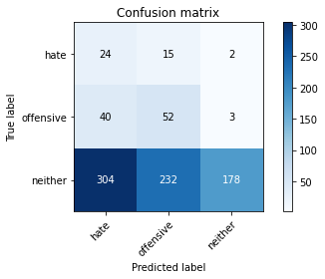

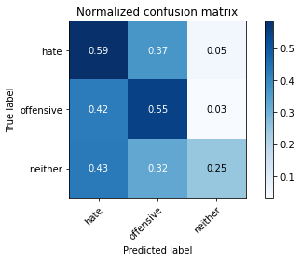

precision recall f1-score support

hate 0.07 0.59 0.12 41

offensive 0.17 0.55 0.26 95

neither 0.97 0.25 0.40 714

accuracy 0.30 850

macro avg 0.40 0.46 0.26 850

weighted avg 0.84 0.30 0.37 850

average eval_loss: 1.385927336853604, accuracy: 0.2988235294117647

training 6 epoch...

1.9492287635803223 seconds used......

6 training finished! average train loss: 0.46519235477728005

evaluating...

Confusion matrix, without normalization

[[ 25 13 3]

[ 40 50 5]

[304 183 227]]

Normalized confusion matrix

[[0.6097561 0.31707317 0.07317073]

[0.42105263 0.52631579 0.05263158]

[0.42577031 0.25630252 0.31792717]]

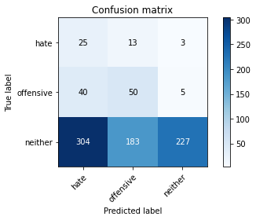

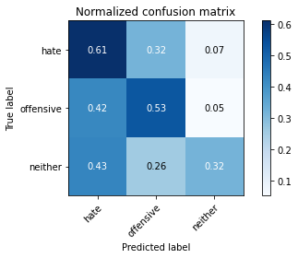

precision recall f1-score support

hate 0.07 0.61 0.12 41

offensive 0.20 0.53 0.29 95

neither 0.97 0.32 0.48 714

accuracy 0.36 850

macro avg 0.41 0.48 0.30 850

weighted avg 0.84 0.36 0.44 850

average eval_loss: 1.3959724750629692, accuracy: 0.3552941176470588

training 7 epoch...

1.9601099491119385 seconds used......

7 training finished! average train loss: 0.2949572056531906

evaluating...

Confusion matrix, without normalization

[[ 19 19 3]

[ 24 66 5]

[200 238 276]]

Normalized confusion matrix

[[0.46341463 0.46341463 0.07317073]

[0.25263158 0.69473684 0.05263158]

[0.28011204 0.33333333 0.38655462]]

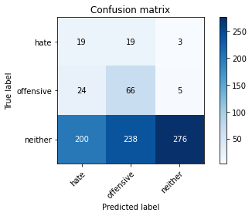

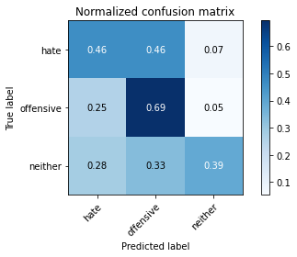

precision recall f1-score support

hate 0.08 0.46 0.13 41

offensive 0.20 0.69 0.32 95

neither 0.97 0.39 0.55 714

accuracy 0.42 850

macro avg 0.42 0.51 0.33 850

weighted avg 0.84 0.42 0.51 850

average eval_loss: 1.3578774974096652, accuracy: 0.42470588235294116

training 8 epoch...

1.9614217281341553 seconds used......

8 training finished! average train loss: 0.16082836073987625

evaluating...

Confusion matrix, without normalization

[[ 9 26 6]

[ 9 80 6]

[112 292 310]]

Normalized confusion matrix

[[0.2195122 0.63414634 0.14634146]

[0.09473684 0.84210526 0.06315789]

[0.15686275 0.40896359 0.43417367]]

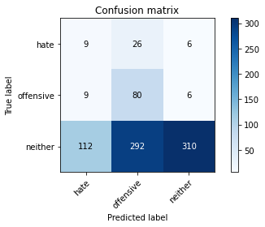

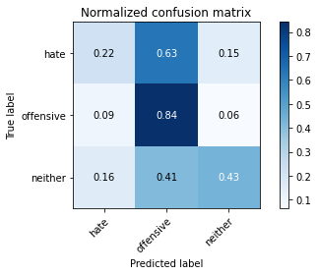

precision recall f1-score support

hate 0.07 0.22 0.11 41

offensive 0.20 0.84 0.32 95

neither 0.96 0.43 0.60 714

accuracy 0.47 850

macro avg 0.41 0.50 0.34 850

weighted avg 0.83 0.47 0.54 850

average eval_loss: 1.320125256859979, accuracy: 0.46941176470588236

training 9 epoch...

2.0062131881713867 seconds used......

9 training finished! average train loss: 0.09313871755319483

evaluating...

Confusion matrix, without normalization

[[ 7 22 12]

[ 7 78 10]

[ 88 226 400]]

Normalized confusion matrix

[[0.17073171 0.53658537 0.29268293]

[0.07368421 0.82105263 0.10526316]

[0.1232493 0.31652661 0.56022409]]

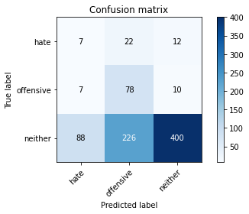

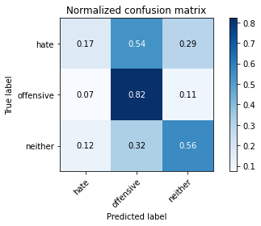

precision recall f1-score support

hate 0.07 0.17 0.10 41

offensive 0.24 0.82 0.37 95

neither 0.95 0.56 0.70 714

accuracy 0.57 850

macro avg 0.42 0.52 0.39 850

weighted avg 0.83 0.57 0.64 850

average eval_loss: 1.115455229961595, accuracy: 0.5705882352941176

training 10 epoch...

1.9566528797149658 seconds used......

10 training finished! average train loss: 0.04150601290166378

evaluating...

Confusion matrix, without normalization

[[ 12 16 13]

[ 11 72 12]

[101 193 420]]

Normalized confusion matrix

[[0.29268293 0.3902439 0.31707317]

[0.11578947 0.75789474 0.12631579]

[0.14145658 0.27030812 0.58823529]]

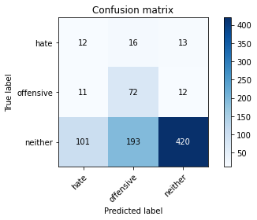

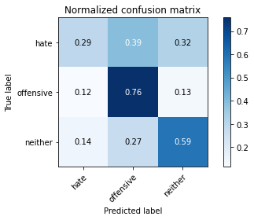

precision recall f1-score support

hate 0.10 0.29 0.15 41

offensive 0.26 0.76 0.38 95

neither 0.94 0.59 0.72 714

accuracy 0.59 850

macro avg 0.43 0.55 0.42 850

weighted avg 0.83 0.59 0.66 850

average eval_loss: 1.1601034151606782, accuracy: 0.5929411764705882